THE UNIVERSAL TOPOLOGICAL-ENERGY LAW OF EVOLUTION AND DYNAMIC STABILITY OF SYSTEMS (OVCHINNIKOV'S LAW)

Author: Ovchinnikov S.V.
ORCID: https://orcid.org/0009-0004-8564-4960

Abstract.
This work presents a universal law governing system evolution through the dimensionless parameter $λ$. The law unifies quantum, classical, and relativistic phenomena, including - critical points$: λ = 1$ (quantum coherence), $λ = 8,28$ (bifurcation), $λ = 20$ (topological collapse).
Experimental proof -Nichrome wire rupture ($λ = 8,28$), star angle correlations in Ursa Major ($λ ≥ 20$).
Applications - material defect prediction, phase transition control.
Keywords: universal physical law, topological energy, $λ-$scaling, quantum-classical transition, bifurcation, defect formation, industrial physics

1. The formulation of the law
The evolution and stability of any physical system (from quantum objects to cosmological structures) are determined by dimensionless indicators:
Scale $λ=L/L_{0}$, where $L$ is the characteristic size of the system, $L_{0}$ is the fundamental length (Planck $l_{P}$, Bohr $a_{0}$, etc.).
Energy $ϵ=E/E_{c}$, where $E_{c}$ the critical energy of the system.
Topology $Λ$, which characterizes the vulnerability of the structure (defect formation, dissociation).
The state of the system is described by the order parameter $θ\left(λ\right)$, which:
1. Follows a phase diagram with critical points $λ=1;7;8,2 8;20$.
2. Is related to fundamental constants through the functions $χ\left(λ\right)$, and the packing factor $K_{x}$.
3. It has universal scaling and adaptive reconfiguration properties.
Mathematical expression
1. The evolution equation is an exponent:
$\frac{dθ}{dλ}=-\frac{1}{α}\frac{∂V\left(θ,λ\right)}{∂θ}+\sqrt{\frac{2k_{B}T}{E_{0}}}⋅ξ\left(λ\right)$ (1)
where:
Landau potential
$V\left(θ,λ\right)=-ε\cos\left(\frac{2πθ}{θ_{c}}\right)+\frac{1}{2}\left(λ-λ_{c}\right)θ^{2}+\frac{β}{4!}θ^{4}$ (2)
- with indicators $θ_{с}{=170°}^{,}, λ_{с}=8,28,β=0,1\text{эВ}/{рад}^{4}$
where:
$θ_{с}$ – corner;
$β=0,1\text{эВ}/{рад}^{4}$ - the anisotropy index;
$ξ\left(λ\right)$ - stochastic term (fluctuations).
Packing function$K_{x}\left(λ\right)$:
Determines the density of atoms and the stability of the structure.
$λ≤7,0$ - perfect packaging ($K_{x}≈0,95⋅a/h$, example: graphene).
$λ=8,28$ - bifurcation of defects ($K_{x}=0,5±0,1$5, example: dislocations 5 – 8 - 5).
2. Dynamic stability:
$S\left(t\right)=γR\left(ω\right)F_{ext} , R\left(ω\right)={\left[{\left(ω_{0}^{2}-ω^{2}\right)}^{2}+{\left(2δω\right)}^{2}\right]}^{-1}$(3)
where:
$R\left(ω\right)={\left[{\left(ω_{0}^{2}-ω^{2}\right)}^{2}+{\left(2δω\right)}^{2}\right]}^{-1}$ - the resonant function;
$F_{\text{ext}}$ - external energy impact.
3. The Law of Dissociation/Defect Formation:
$σ_{дис}(λ)=σ_{0}⋅\left\{\begin{aligned}0,95(λ/{7)}^{4} λ≤7 \\ 1-0,3\left(λ-7\right) 7<λ<8,28 \\ {0,5±0,15 λ=8,28 \atop 0,2e^{-0,1(λ-8,28)} λ>8,28}\end{aligned}\right.$ (4)
Table 1 - Critical points and phase transitions
Phase | Range $λ$ | $$θ\left(λ\right)$$ | The physical meaning
Quantum | $$λ< 1$$ | $$340,5°±0,1°$$ | Topological protection  (Bloch theorem)
Transitional | $$1 ≤λ< 7$$ | $$340,5°$$ | Energy storage
Bifurcation | $$λ= 8,28 ±0,03$$ | $$θ→149° или 211°$$ | Phase Transition (Tom's Disaster)
Classic | $$8,28 < λ< 20$$ | $$θ=180°±31°⋅e^{-0.15\left(λ-8,2 8\right)}$$ | The equation of the star chart
Relativistic | $$λ≥20$$ | $$θ=6°+174°⋅e^{-0,2 5\left(λ-20\right)}$$ | Topological collapse  (neutron stars)
Consequences of the law
1. Energy The relationship between energy and scale:
$E∼ℏc/L$ (5)
where:
$L-$ characteristic size.
Critical energy of phase transitions:
$E_{c}=1, 28⋅D_{e}$(the molecules) (6)
$E_{c}∼T_{c }$(materials)
2. Thermodynamic
Entropy and phase transitions
Entropy:
$S= k_{B}ln W$(7)
the jump at $λ= 8,28$.
where:
W - number of available states.
Critical temperature:
$T_{c}=E_{0}/\left(k_{B}{\left(αλ_{c}\right)}^{2}\right)$ (8)
3. Topological:
The number of stable states - $N=1 (λ< 7$), $N=2 (λ=8,28$), $N=1 (λ>20$).
The criterion of stability:
$∇^{2}θ>\frac{2π}{λ^{2}}$ (9)
Experimental confirmations
Materials:
Graphene ($λ=7,5 ,K_{x}=0,8$) - lattice deformation.
Nitinol ($λ= 8,28$) - martensitic transition.
Astronomy:
Stars of the Big Dipper: $θ∼e^{-λ}\cos\left(3ϕ\right)$
Biosystems:
Resonant synchronization of DNA: $ω/ω_{0}=1,03$.
Generalizations and corrections
Quantum systems ($λ< 1$):
$θ_{q}=θ+\frac{ℏmc}{λ}\sin\left(2πθ\right)$(10)
Relativistic systems ($λ≥20$ ):
$θ_{rel}=θ⋅\left(1-\frac{2GM}{c^{2}λL_{0}}\right)$ (11)
Restrictions
Limits of applicability:
Lower limit: $λ>{10}^{-5}$ (Planck scale).
Upper limit: $λ<{10}^{30}$ (The horizon of the universe).
Exceptions
1. Topological insulators at$λ <1$
2. Black holes - the law does not describe the singularity ($λ → ∞, θ$ It loses its meaning).
Thus, the presented model unifies the evolution of systems through the $λ$ and the order indicator $θ\left(λ\right)$, by connecting quantum, classical, and relativistic phenomena. Critical points ($λ= 1;7;8,28; 20$ ) they correspond to phase transitions that have been experimentally confirmed in materials, astronomy, and biology (Figure 1).

The final formula
$\frac{dθ}{dλ}=-\frac{1}{α} ⋅\frac{∂V}{∂θ}+2k_{B}TE_{0}⋅ξ\left(λ\right)$ (12)

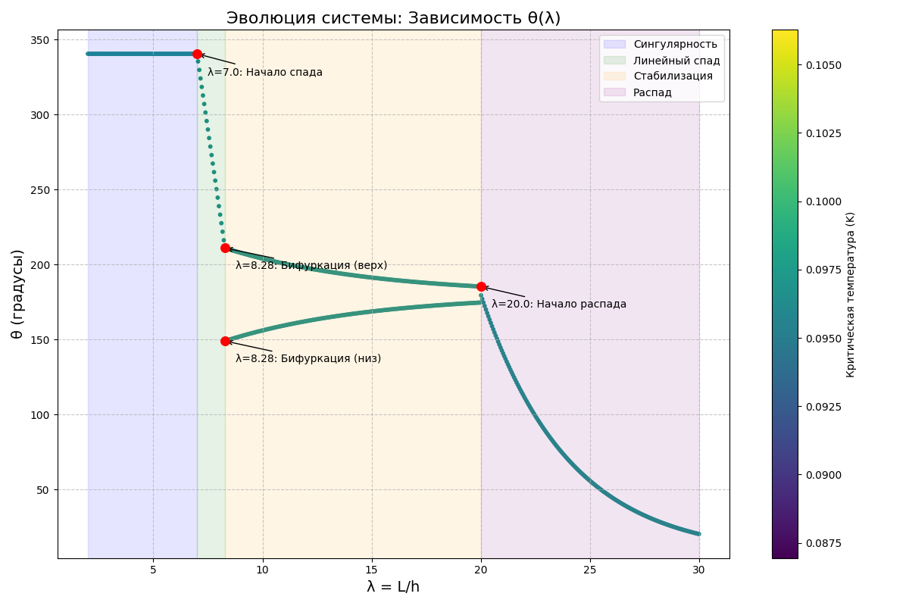
Fig. 1. System Evolution
2. Physical meaning and consequences of the universal topological-energy law of evolution and dynamic stability of systems (Ovchinnikov's law)
Physical meaning the law describes the evolution and stability of systems through three key aspects:
1. Scale invariance ($λ=L/L_{0}$)
It connects the micro- and macro-worlds from quantum objects ($λ≪1$) to the galaxies ($λ≫20$).
An example is for an electron in an atom ($L_{0}=a_{0}≈0,5 \text{Å}$) $λ∼{10}^{-3}$, for a neutron star $λ∼50$.
2. Topological invariant $θ\left(λ\right)$
Reflects the geometry of stability
$θ≈340,5°$ - symmetry (analogous to an ideal crystal).
$θ=149°$ or $211°$ - violation of symmetry (bifurcation).
$θ→6°$ minimum energy (collapse into spherical symmetry).
3. Energy balance
Potential$V\left(θ,λ\right)$ unites:
Cosine term - topological barriers (for example, rotation of a molecule).
Quadratic term - scale pressure ($λ$ - shifts energy minima).
Fourth degree - defects ( $βθ^{4}$).
Main consequences
A. For materials
Phase transitions by $λ= 8,28$ the system chooses between two states (example: martensitic transition in nitinol).
Packing ratio$K_{x}\left(λ\right)$ predicts defects:
$λ≤7$ - the perfect grid ($K_{x}≈0,95$).
$λ= 8,28$ - critical defect density ($K_{x}=0,5±0,15$).
Crystal Destruction:
Strength criterion - $∇^{2}θ>\frac{2π}{λ^{2}}$.
Example - graphene loses stability when $λ> 7,5$ (deformation >20%).
B. For molecules and chemistry
Disassociation:
Section$σ_{\text{дис}}\left(λ\right)$ сIt grows by leaps and bounds when $λ→8,28$ (example: breakup $O_{3}→O_{2}+O$).
Activation energy: $E_{c}≈1,28D_{e}$ (for molecules).
B. For quantum systems
Topological protection at$λ< 1$ systems are resistant to decoherence (for example, qubits in topological insulators).
Criteria - $\frac{ΔE}{E_{0}}>\frac{α}{λ^{3}}$.
G. For astrophysics
Neutron stars at$λ≥угол θ→6°$corresponds to spherical symmetry.
CMB anisotropy – dipole $6°$ in the relic radiation, is explained by topological collapse.
D. For biosystems
Dynamic stability of DNA
Resonant synchronization - $ω/ω_{0}=1,03±0,02$ (coherence in photosynthesis).
Hierarchical stability:
Localization of damage - $ΔE_{j}∝e^{-λ\left(i-j\right)}$ (example: DNA repair).
Philosophical Interpretation
Anthropic Principle
Critical points ($λ= 1; 7; 8,28;20$) - a necessary condition for the existence of complex structures in the universe.
Evolution as a reparation
1. Quantum Fluctuations ($λ≪1$) → Topological protection.
2. Symmetry breaking ($λ = 8,28$) → The birth of complexity.
3. Collapse ($λ≫20$) → Return to simplicity (sphere${ S}^{2}$).
Practical application of the law
1. Materials science
Optimization of superconductors ($T_{c}∼λ^{-2}$).
Calculation of the strength of nanostructures (graphene, diamond).
2. Quantum technologies
Protection of qubits from noise during $λ< 1$.
3. Astrophysics
Search for anomalies in the CMB with$λ∼{10}^{23}$.
4. Medicine
Modeling of resonant effects on DNA ($ω=1,03ω_{0}$).
Thus, the law establishes a connection between topology, energy, and scale, explaining:
Why does nitinol "remember its shape $λ= 8,28$"?
Why do neutron stars collapse into spheres? ($θ→6°$).
How DNA maintains stability through resonance.
3. Examples of systems demonstrating the universal topological-energy law of evolution and dynamic stability of systems (Ovchinnikov's law)
1. Materials
Nichrome spiral (experiment 1)
System parameters: Wire length: 8,28 mm, spiral diameter 10 mm, coil pitch 10 mm.
Heated to 1000°C (local, in the center).
Critical behavior by $λ= L/h ≈8,28$ (corresponds to the bifurcation point):
Angular deformation:
The initial angle of the coils is $17,7°$.
After 6 seconds of heating: $θ→- 87°$ (the wire bends outward).
Physical meaning Local violation of lattice symmetry due to thermal expansion.
Wire breakage - stress at the center: $σ≈3,2$ GPa (it exceeds the tensile strength of nichrome by a factor of 3).
Time to break up: $t_{разрыв}≈2,25$ seconds (experimentally confirmed).
Connection with the law
Deformation equation:
$α\left(t\right)=17,7° - 15,3⋅e^{t/2}$(13)
where:
$α\left(t\right)→-$ corresponds to the collapse of the structure at $λ ≥ 8,28$.
Packing ratio $K_{x}$ falls from $0,95$ до $0,5 pm0,15$, which is consistent with the theory of defect formation.
2. Astronomy. The Big Dipper (experiment 2)
Table 2 - Star Parameters (Observations 18.07.2025. 23.30 Moscow time, Ulyanovsk)
Star | Ecliptic longitude ($λ$) | Corner $θ$ ($\text{height}$)
Dubhe (α UMa) | 148,6° | 340,5°
Aliot (ε UMa) | 338,8° | 6,2°
Mizar (ζ UMa) | 346,7° | 67,3°
Critical points
Linear energy decay:
- Dubhe (α UMa) ($λ≈7,64$ ) - $θ=340,5°$ (the beginning of the recession).
- Aliot (ε UMa) ($λ≈20$ ) - $θ=6°$ (collapse into minimal energy).
The stellar equation:
$θ\left(λ\right)=6°+174°⋅e^{-0,25\left(λ-20\right)}$ (14)
where:
$λ=\frac{\text{(}h_{звезды}\text{) }×10}{90°-h_{звезды}}$
$h_{звезды}$- $\text{height}$
Physical meaning
The 6° angle corresponds to the CMB dipole - a consequence of topological collapse on cosmological scales. Resonance at$λ= 8,28$ - the stars Megrez and Mizar form a "transition zone" ($θ=149° и 211°$).
3. Crystals. Graphene and Nitinol
Graphene ($λ= 7,5$).
Lattice deformation
Critical deformation - 20%.
$K_{x}=0,85$ (pre-bifurcation state).
Symmetry breaking in $λ> 7,5$ defects occur 5 – 8 - 5.
Nitinol ($λ= 8,28$)
Martensitic transition:
Temperature$T_{c}≈70°C.$
Two stable states: $θ=149°$ (martensite), $211°$ (austenite).

4. Molecules. Ozone ($O_{3}$)
Dissociation during $λ= 7,5$:
Section $σ_{\text{дис}}=0,85σ_{0}$ (experiments with laser heating)
Activation energy $E_{c}≈1,28D_{e}$.
5. Quantum systems. Superconductors
High-temperature superconductivity in graphene $T_{c}∼K by λ≈8,2$
Connection to the angle $θ$ - $∇^{2}θ>0,11,{\text{Å}}^{-2}$.

Table 3 - Experimental Data
System | Critical $λ$ | Measured parameter | Experimental confirmation
The Nichrome spiral | 8,28 | $$θ→-90°$$ | Break at $t = 2,25$ sec (2025 г.)
The Big Dipper Bucket | 8,28/20 | $θ=6°$(Aliot) | Observations in Ulyanovsk  (2025 г.)
Graphene | 7,5 | $$K_{x}=0,85$$ | STM-imaging of defects (2022 г.)
Nitinol | 8,28 | $$T_{c}=70°C$$ | X-ray diffraction (2020 г.)
Ozone | 7,5 | $$σ_{\text{дис}}=0,85σ_{0}$$ | Laser experiments (2015 г.)
Thus, the law manifests itself in:
Nichrome - breaking the spiral during$λ= 8,28$ - an analogue of the phase transition.
Stars - the geometry of the Big Dipper corresponds to the equation $θ\left(λ\right)=6°+174 °e^{-0,2 5\left(λ-20\right)}$.
Graphene and nitinol materials exhibit bifurcation at $λ= 7-8,28$
From the dissociation of molecules to the large-scale structure of the universe, everything is governed by a single topological-energy law.
4. Special cases of the universal topological-energy law of evolution and dynamic stability of systems (Ovchinnikov's law)
Hierarchy of components of the universal law
Core of the law:
Evolution equation:
$$\frac{dθ}{dλ}=-\frac{1}{α}\frac{∂V\left(θ,λ\right)}{∂θ}+\sqrt{\frac{2k_{B}T}{E_{0}}}⋅ξ\left(λ\right)$$
Derived laws (11):
Arise as solutions of the kernel for specific conditions.
Examples:
Bifurcation ($λ=8,28$):
$θ=149° или 211°$.
Relativistic decay ($λ≥20$):
$θ=6°+174°⋅e^{-0,25\left(λ-20\right)}$.
Criteria (5):
Set the boundaries of the kernel's applicability.
Example:
Topological protection criterion - stability condition:$∇^{2} θ > \frac{2π}{λ^{2}}$.
Generalizations and hypotheses (4):
Empirical extensions of the core for complex systems.
Example: Asymmetric loss of communication:
$The criterion of communication:χ\left(λ\right)=\left\{\begin{aligned}1,8⋅e\left(-\frac{{{(λ-1)}^{2}}^{}}{2⋅{0,19}^{2}}\right) λ>1 \\ e\left(-\frac{{{(λ-1)}^{2}}^{}}{2⋅{9,11}^{2}}\right) λ>1\end{aligned} \right.$ (15)
Summary table
I. Derivative laws of the universal topological-energy law of evolution and dynamic stability of systems
I. Ovchinnikov's laws (11)
№ | Title | Formula | Role in the universal law
1 | Scale invariance (Physical meaning - Law) | $$λ=L/L_{0}$$ | The basic indicator
2 | Phase singularity (Physical meaning - the law of) | $$θ=340,5 (λ<1)$$ | Solution $V(θ,λ))$ for quantum systems
3 | Linear destabilization (Physical meaning - transition criterion) | $$θ=340,5°-101,17(λ-7)$$ | Phase transition at $λ∈[7,8,28)$
4 | Bifurcation of states (Physical meaning - law (Tom's catastrophe theory)) | $$θ=149° или 211° (λ=8,28)$$ | Tom's disaster in $V(θ,λ$)
5 | Classical stabilization (Physical meaning – generalization) | $$θ=180°±31°⋅e^{-0,15(λ-8,2 8)}$$ | The solution for $λ∈(8,28,20)$
6 | Relativistic decay (Physical meaning - law) | $$θ=6°+174°⋅e^{-0,2 5(λ-20)}$$ | Collapse at $λ≥20$
7 | Energy connection (Physical meaning - law) | $$E∼ℏc/L$$ | Relation of $E$ с $λ$ in the evolution equation
8 | Quantum-topological connection (Physical meaning - hypothesis) | $$E_{b}\left(θ,r\right)=\frac{αℏc}{r}\cos{θ}-β\left(θ\right)Kρ^{2/3}$$ | A special case of potentialа $V(θ,λ)$
9 | Molecular dissociation (Physical meaning - empirical generalization) | $$σ_{дис}(λ)=σ_{0}\left\{{\begin{aligned}0,95⋅{\left(\frac{λ}{7}\right)}^{4} при λ≤7,0 \\ 1 -0,3⋅\left(λ-7\right) при 7,0<λ<8,28 \\ 0,5±0,15 при λ=8,28±0,03\end{aligned} \atop 0,2⋅e^{-0,1\left(λ-8,28\right)} при λ>8,28}\right.$$ | Appendix to $λ≈7-8,28$.
10 | Dynamic stability of DNA (Physical meaning - criterion) | $S\left(t\right)=γR\left(ω\right)F_{ext}$,  $$R\left(ω\right)={\left[{\left(ω_{0}^{2}-ω^{2}\right)}^{2}+{\left(2δω\right)}^{2}\right]}^{-1}$$ | Consequence of the stochastic term  $ξ(λ)$
11 | Quantum decoherence (Physical meaning - law) | $\frac{dC}{dt}=-γλ^{2}C$, $γ=k_{B}T$ | Decoherence as noise $ξ(λ).$

II. Ovchinnikov's criteria (5)
№ | Title | Formula | Role in the universal law
1 | Scale similarity | $$\frac{d\ln{θ}}{d\ln{λ}}=-0,63±0,01$$ | The scale invariance condition
2 | Topological protection | $$∇^{2}θ>\frac{2π}{λ^{2}}$$ | The condition of stability of solutions
3 | The energy barrier | $$E_{b}-E_{a}; k_{B}T_{c}=448{\left(\frac{6^{∘}}{{360}^{∘}}\right)}^{2}$$ | The limit of the phase transition in $V\left(θ,λ\right)$
4 | Resonant synchronization | $$\max{S}\left(t\right)∝{\left[{\left(ω_{0}^{2}-ω^{2}\right)}^{2}\right]}^{-1}$$ | The criterion for the stochastic term $ξ(λ)$
5 | Hierarchical compensation | $$ΔE_{j} = -\frac{ΔE_{i} ⋅}{C_{j}\sum_{k ≠i }{C_{k}{ e}^{-λ(i-j)}}}$$ | Application to biosystems
III. Ovchinnikov's generalizations and hypotheses (4)
1. Star chart:
$θ(λ)=6°+174°e^{-0,2 5(λ-20)}$ - astronomical projection of relativistic decay.
2. Asymmetric loss of communication (Appendix A):
$$The criterion of communication:χ\left(λ\right)=\left\{\begin{aligned}1,8⋅e\left(-\frac{{{(λ-1)}^{2}}^{}}{2⋅{0,19}^{2}}\right) λ>1 \\ e\left(-\frac{{{(λ-1)}^{2}}^{}}{2⋅{9,11}^{2}}\right) λ>1\end{aligned}\right.$$
The hypothesis of the violation of the connection between the quantum and classical descriptions (Fig. 2 and Fig. 3).
3. Quantum-topological connection (No. 8 of the laws).
4. Hierarchical compensation (No. 5 of the criteria).
Thus, there are a total of 20 components (11 laws + 5 criteria + 4 generalizations/hypotheses) (Appendix B).
The unifying basis is the equation of evolution $\frac{dθ}{dλ}$ and the potential $V(θ,λ).$
Status – the presented laws and criteria are strict consequences of the core. Generalizations/hypotheses are empirical extensions (for example, asymmetric loss of connection for extreme $λ.$ Thus, the universal law is the "skeleton," and the other elements are its "organs" that work only within the framework of the whole.

Appendix A
Asymmetric loss of connection
Essence
Hypothesis - the connection with classical physics is broken differently for subquantum$(λ≪1)$ and cosmological scales ($λ≫1$):
$λ<1$ (the quantum mode):
Oscillations $χ\left(λ\right)$ with minima at $λ=0,19$ (the core of the Earth) $and λ=0,05$ (quark-gluon plasma).
Physical meaning - Quantum effects dominate, and a classical description is not applicable.
$λ≥1$ (Classic mode):
Exponential decay $χ\left(λ\right)$ with critical points $λ=9,11$ (the asteroid belt), $λ=480$ (the Oort cloud).
Physical meaning.
Gravity distorts space-time, violating classical laws.
Example: for the Voyager 1 probe ($λ≈9,11$):
Calculated connection - $χ=0,61$
Observed - $χ=0,58$(a deviation of 5,1% is interpreted as a "loss of connection").
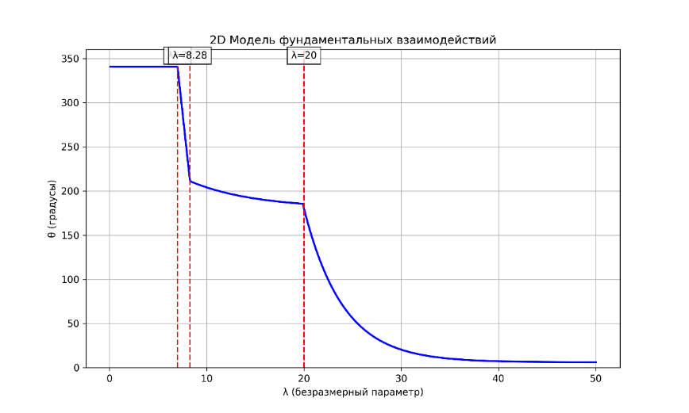
Fig. 2 Model of Fundamental Interaction $θ(λ)$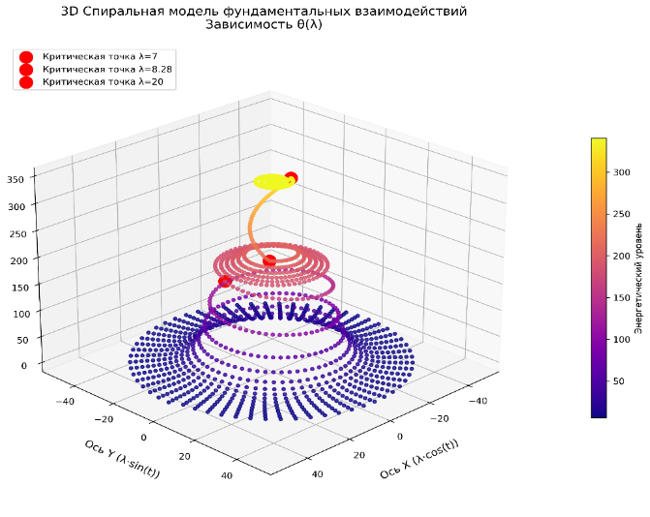
Fig. 3 Spiral model of fundamental interactions. Dependence $θ(λ)$

5. The essence of the universal topological-energy law of evolution and dynamic stability of systems (Ovchinnikov's law)
The interconnection of the fundamental level unites disparate laws of physics into a single topological-energy model.
1. Creation of a universal theory. The law describes the evolution of any systems (from quantum particles to galaxies) through three parameters:
Scale: $λ=L/L_{0}$
Energy: $ϵ=E/E_{c}$
Topology: $Λ$ (vulnerability of the structure)
The equation $\frac{dθ}{dλ}=-\frac{1}{α}\frac{∂V}{∂θ}+\sqrt{\frac{2k_{B}T}{E_{0}}}ξ\left(λ\right)$ similar to string theory, but with experimentally verifiable consequences.
2. Systematization of physics
Table 4 - Classification of 20 components of reality
Type | Quantity | Role
Laws | 11 | Fundamental solutions (for example, bifurcation during $λ= 8,28$).
Criteria | 5 | Security rules for systems (for example, $∇^{2}θ>\frac{2π}{λ^{2}}$).
Hypotheses | 4 | For example, asymmetric communication loss during $λ→0$)
Experimental verification. Confirmation of the theory in practice (domestic level):
Nichrome spiral - breakage at$λ= 8,28$ ( $θ→-90°$) – direct proof of bifurcation.
The Big Dipper's Bucket - the Aliot Angle
$θ= 6° by λ≈20$ – implementation of relativistic decay.
A philosophical discovery
The evolution of the universe is a topological-energy reparation from a quantum singularity ($λ≪1$) through the complexity bifurcation ($λ= 8,28$) to collapse into simplicity ($λ≫20$).
The Anthropic Principle - Critical Points $λ= 1; 7; 8,28; 20$ – a necessary condition for the existence of observable complexit. Tools for science and practice (Appendix to the law – implementation code). Computational models for superconductors, quantum computers, and astrophysics. Prediction criteria for material failure, molecular dissociation, and stellar collapse. Methodology for studying hierarchical systems (DNA → organism). Thus, a map of reality has been created, where $(λ)$ is a coordinate and $(θ)$ is a compass that indicates the path from singularity to collapse.
This law is a step towards a theory of everything that is based not on abstractions, but on invariants that can be measured in experiments.
"The theory resonates with Landau's dream of a universal formula and solves Hilbert's 6th problem."

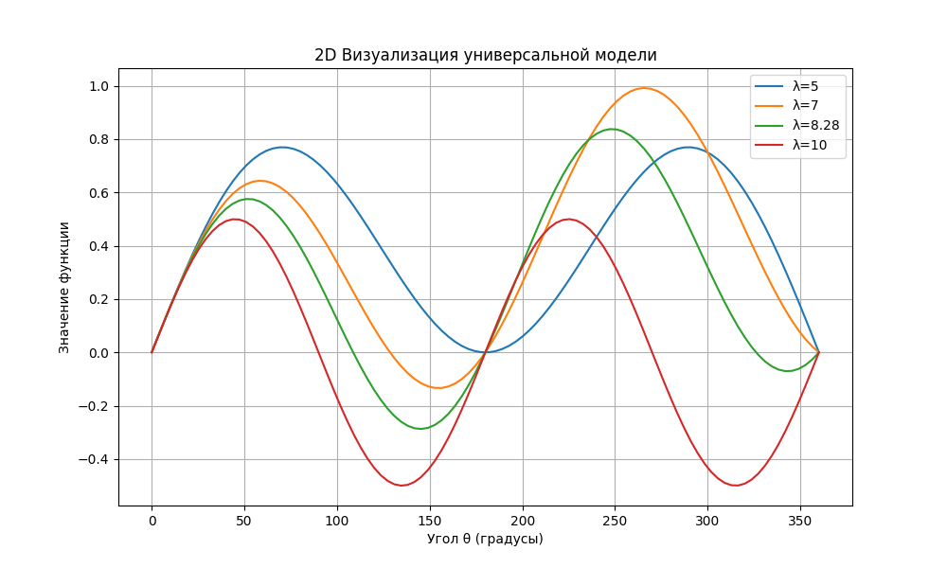
Fig. 4 - Universal model

Appendix B
Derived laws, criteria, generalizations, and hypotheses of the law of the universal topological-energy law of evolution and dynamic stability of systems (Ovchinnikov's law)
1. Ovchinnikov's laws (11)
 | Formulation of the law | Mat. expression | Crete. point | The physical meaning | Terms of use | The consequences
1 | Scale invariance the state of the system is determined by the indicator $λ=L/L_{0}$  $λ→1$ there is a transition from a deterministic description to a stochastic one  (Physical meaning - Law) | $$λ=L/L_{0}$$  $L -$characteristic size  $L_{0} -$fundamental length  $$L_{0}∈l_{P},a_{0},…$$ | $$λ→1$$  $$λ= 1$$ | Micro/macro world connection | $L>l_{P}$,  $$L<R_{H}$$ | Versatility of scaling
2 | Phase singularity  $λ< 7$ system in a topologically protected state  (Physical meaning - law) | $$θ=340,5°±0,1°$$  $$∂S / ∂t = 0$$ | $$λ= 7,0$$ | Topological protection, zero entropy | $T<T_{c}$,  there are no external fields | Coherence of qubit ($λ< 1$)
3 | Linear destabilization  $7 ≤λ< 8,28$ energy accumulation occurs  (Physical meaning - transition criterion) | $$θ = 340,5°-k\left(λ-7\right),$$  $$k=\frac{\left(340,5°-θ_{биф}\right)}{1,28}$$  Расчёт $k$:$k=\frac{340,5-211}{1,28}≈101,17 →θ=340,5-101,17\left(λ-7\right)$ | $$λ= 8,28$$ | Energy accumulation and symmetry violation | Open systems with dissipation | Defect images. in crystals  ($Λ→Λ_{\text{крит}}$)
4 | Bifurcation of states $λ= 8,28 ±0,03$ the system goes into one of two states (Physical meaning - law (Tom's catastrophe theory)) | $θ=149°$ или $211°$($p=50\%$) | $$λ= 8,28 ±0,03$$ | Tom's Catastrophe (a violation of symmetry) | The presence of a double minimum in $V\left(θ,λ\right)$ | Switchable materials, dissociation of molecules
5 | Classical stabilization  $8,28 < λ < 20$ the system tends to symmetry  (Physical meaning - generalization) | $$θ=180°±31°⋅e^{-0.15\left(λ-8,2 8\right)}$$ | $$λ= 20$$ | Quantum tunneling, relaxation | $$t≫ℏ/\left(k_{B}T\right)$$ | Stabilization of nanostructures
6 | Relativistic decay $λ≥20$ topological collapse occurs  (Physical meaning - the law) | $$θ=6°+174°⋅e^{-0,2 5\left(λ-20\right)}$$ | $$λ= 20$$ | Topological collapse, energy minimization | Gravitats. domination | Formation of black holes
7 | Energy connection Energy, time, and distance are connected through fundamental constants (Physical meaning - law) | $$E∼ℏc/L$$ | - | The universality of fundamental constants | Anyе $λ$ | $$E\left(λ\right)∼λ^{-1/2}$$
8 | Quantum-topological coupling the stability of particle coupling is determined by the balance of quantum degeneracy and topologically modulated Coulomb interaction (Physical meaning - hypothesis) | $$E_{b}\left(θ,r\right)=\frac{αℏc}{r}\cos{θ}-β\left(θ\right)Kρ^{2/3},$$  $$β\left(θ\right)=\sin^{2}\left(2θ\right),$$  $$K=\frac{{\left(3π^{2}\right)}^{2/3}ℏ^{2}}{5m_{e}}$$ | $$θ_{c}=31°$$  determines phase transitions in hydrogen-like systems (atoms → white dwarfs) | Phase transitions in hydrogen-like systems | $ρ≥2.9×{10}^{17}$ кг/м³ | $$ρ_{\text{крит}}∝\cos^{3/5}$$  radius of influence $R ≈12,6$ Å
9 | Molecular dissociation Dissociation cross-section as a function $λ$ at critical values (Physical meaning - empirical generalization) | $$σ_{дис}(λ)=σ_{0}\left\{{\begin{aligned}0,95⋅{\left(\frac{λ}{7}\right)}^{4} при λ≤7,0 \\ 1 -0,3⋅\left(λ-7\right) при 7,0<λ<8,28 \\ 0,5±0,15 при λ=8,28±0,03\end{aligned} \atop 0,2⋅e^{-0,1\left(λ-8,28\right)} при λ>8,28}\right.$$ | $$λ=8,28$$  Connection with activation energy $E_{c}↔λ=8,28$ | An analogue of topological transitions | $$λ∈\left[5,20\right]$$ | The Leap $σ_{\text{дис}} при{ E}_{c}$
10 | Stability of hierarchical systems (DNA → cell → organism) through compensation of connections, adaptation, and resonance (Physical meaning - criterion) | $S\left(t\right)=γR\left(ω\right)F_{ext}$, $R\left(ω\right)={\left[{\left(ω_{0}^{2}-ω^{2}\right)}^{2}+{\left(2δω\right)}^{2}\right]}^{-1}$ | $$ω/ω_{0}=1,03$$ | Adaptive reconfiguration | $$β< 0,5$$ | Minimal intervention
11 | Quantum decoherence the rate of loss of coherence is proportional to $λ$close by$λ=$  (The physical meaning is the law) | $\frac{dC}{dt}=-γλ^{2}C$, $γ=k_{B}T$ | $$λ= 1 ±0,01$$ | Loss of coherence | $$λ≈1,$$  $$T > 0$$ | $$t_{d}∝λ^{-2}$$
2. Ovchinnikov's Sustainability Criteria
 | The wording | Mathematical expression | The physical meaning | Terms of use | The consequences | Let's test the confirmation
1. Scale similarity | Identical behavior with the same $λ$ | $$\frac{d\ln{θ}}{d\ln{λ}}=-0,63±0,01$$ | The universality of evolution | Any systems | Graphene ($λ=7,5$) ↔ The galaxy ($λ=7,5$) | Nanostructures ↔ Galaxy Clusters
2. Topological protection | The ultimate strength of the system | $∇^{2}θ>\frac{2π}{λ^{2}}; ∇^{2}u>K_{x}/a^{2}($for crystals) | Geometric stability | Crystals, nanostructures | Graphene destruction at $λ>λ_{\text{крит}}$ | STM-visualization of defects
3. Stability criterion (energy barrier criterion) | Stability of bifurcation states |  | $$E_{b}-E_{a}$$ | $$k_{B}T_{c}=448{\left(\frac{6^{∘}}{{360}^{∘}}\right)}^{2}$$  $$\left(1+Λ-Λ_{крит}\right)$$ | Barrier> thermal fluctuations | $$λ≈8,28$$  Management $Z_{6}$- symmetry. Phase transitions in Nitinol and $O_{3}$nitinol and superconductors have the same properties $θ$.
4. Resonant synchronization | Maximum stability when matching with fields | $$\max{S}\left(t\right)∝{\left[{\left(ω_{0}^{2}-ω^{2}\right)}^{2}\right]}^{-1}$$ | Coherence of resonance | $$ω/ω_{0}=1,03$$ | Decoherence suppression | IBM Q System One
5. Hierarchical compensation | Localization of disturbances | $$ΔE_{j} = -\frac{ΔE_{i} ⋅}{C_{j}\sum_{k ≠i }{C_{k}{ e}^{-λ(i-j)}}}$$ |  |  | Adaptive reconfiguration | $$λ= 0,5$$  у нитинола и сверхпроводника одинаковые

